**Practical No. 3: Write a program to design simple calculator with the use of Grid Layout.**

1. **Write a program to generate following output.**

**Program:**

import java.awt.*;

public class pract3_ex1 extends Frame

{pract3_ex1()

{setVisible(true);

setSize(500,500);

setLayout(new GridLayout(3,2,30,30));

Button btnarray[] = new Button[5] ;

for(int j=0;j<6 ; j++)

{

String s = "Button " + (j+1);

btnarray[j] = new Button(s);

add(btnarray[j]); }

}

public static void main(String []args)

{

new pract3_ex1();

}

}

**Output:**

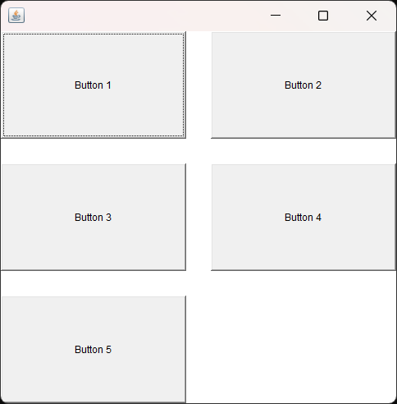

1. **Write a program to generate following output using Border Layout**

**Program:**

import java.awt.*;

public class pract3_ex2 extends Frame

{pract3_ex2()

{

setSize(500,500);

setVisible(true);

setLayout(new BorderLayout(00,00));

Button b1,b2,b3,b4,b5;

b1 = new Button("North");

b2 = new Button("South");

b3 = new Button("East");

b4 = new Button("West");

b5 = new Button("Center");

add(b1,BorderLayout.NORTH);

add(b2,BorderLayout.SOUTH);

add(b3 , BorderLayout.EAST);

add(b4 , BorderLayout.WEST);

add(b5 , BorderLayout.CENTER);

}

public static void main(String[] args) {

new pract3_ex2();

}

}

**Output:**

